Employees Insights Report
Prepared by : Osama Almomani Date : 29/4/2026

TABLE OF CONTENTS

1. Data Overview 3
2. Hiring Trends 3
3. Gender & Age 4
4. Geographic & Diversity 5
5. Department & Business Unit 6
6. Correlation Analysis 7

1. Data Overview :
This report provides a comprehensive overview of our organization's workforce based on data from 988 employees. 904 are currently active and 84 have exit the organization. The company operates across 3 countries and 13 cities, with employees distributed across 7 departments and 4 business units. The average employee age is 44 years, and the average annual salary stands at $114,187. The workforce maintains a near-equal gender balance, with 52% female and 48% male employees.

988  Total Employees | 904 / 84  Active / Exit | 52.2% / 47.8%  Female / Male | $113,333  Avg. Annual Salary
44 yrs  Avg. Employee age | 7  Departments | 3  Countries | 4  Ethnicity

2. Hiring Trends:
The chart illustrates hiring activity from 1992 to 2021. The organization started with modest hiring in the early 1990s, with 9 employees hired per year. Growth remained steady but slow through the 1990s and early 2000s.
A notable increase began around 2008–2009 with 38 hires, followed by consistent growth through the 2010s. The most significant surge occurred in 2021, reaching a peak of 79 new hires (the highest in the company's history).
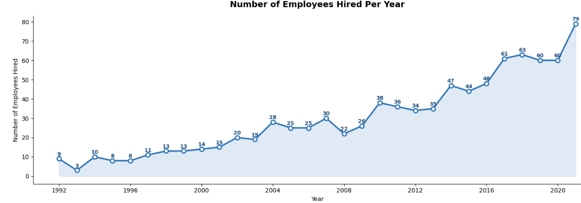
Figure 1: Annual Hiring Trends (1992–2021)

3. Gender & Age:
The workforce demonstrates a balanced gender distribution, with 52% female and 48% male employees out of 904 active staff. This near-equal split reflects inclusive hiring practices across the organization.
In terms of age, the average employee is 44 years old. The largest age group is 50+ with 308 employees (35%), followed by 40–49 with 256 employees (29%). Employees under 30 represent the smallest group at 108 employees (12%).
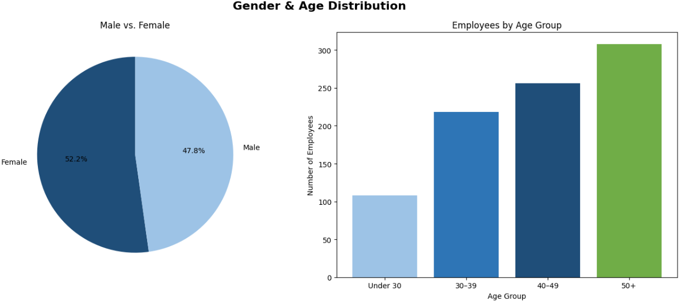

Figure 2: Gender & Age Distribution

4. Geographic & Diversity:
The organization operates across 3 countries and 13 cities. The United States hosts the majority of the workforce with 578 employees (64%), followed by China with 195 employees (22%) and Brazil with 126 employees (14%). This distribution highlights North America as the operational core, with a meaningful presence in Asia and Latin America.
In terms of ethnic diversity, Asian employees form the largest group representing 40% of the active workforce, followed by Caucasian at 27%, Latino at 26%, and Black employees at 7%. The organization demonstrates a multi-ethnic workforce across all its regions of operation.
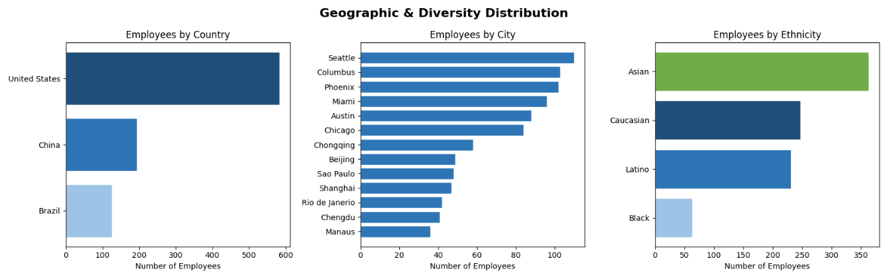
Figure 3: Geographic & Ethnic Diversity

5. Department & Business Unit
The organization spans 7 departments and 4 business units. IT is the largest department with 221 employees (24%), while Accounting is the smallest with 89 employees (10%). Despite its size, IT records the lowest average salary at $97,732, whereas Marketing leads compensation at $130,416.
Across business units, the number of employees is evenly distributed between 22% and 27%. Corporate leads in average salary at $122,083 while Manufacturing is the lowest at $104,085.
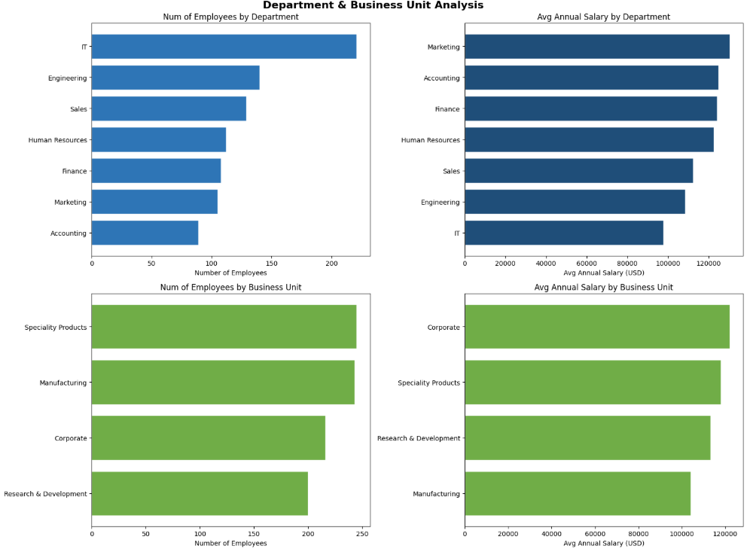
Figure 4: Department & Business Unit Overview

6. Correlation Analysis :
The heatmap below examines the relationship between three key numeric variables (Age, Annual Salary, and Bonus %).
The strongest relationship is between Annual Salary and Bonus %, with a correlation of 0.93. This means that as salary increases, bonus percentage increases almost proportionally — suggesting that bonuses are largely salary-driven rather than performance-driven.
Age and Annual Salary show a near-zero correlation, indicating that years of age alone do not determine an employee's salary level. Similarly, Age and Bonus % have no meaningful relationship.
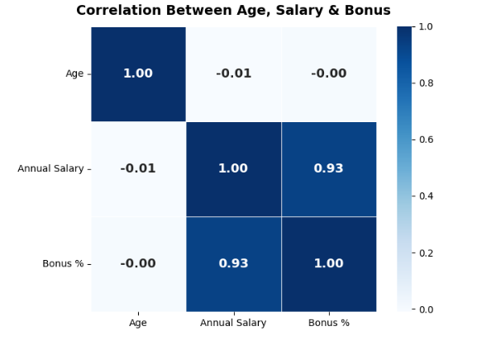
Figure 5: Correlation Heatmap (Age, Salary & Bonus %)

